**Date:** 25th August, 2025

**Program Title:** Vacuum Cleaner

**Observation:**

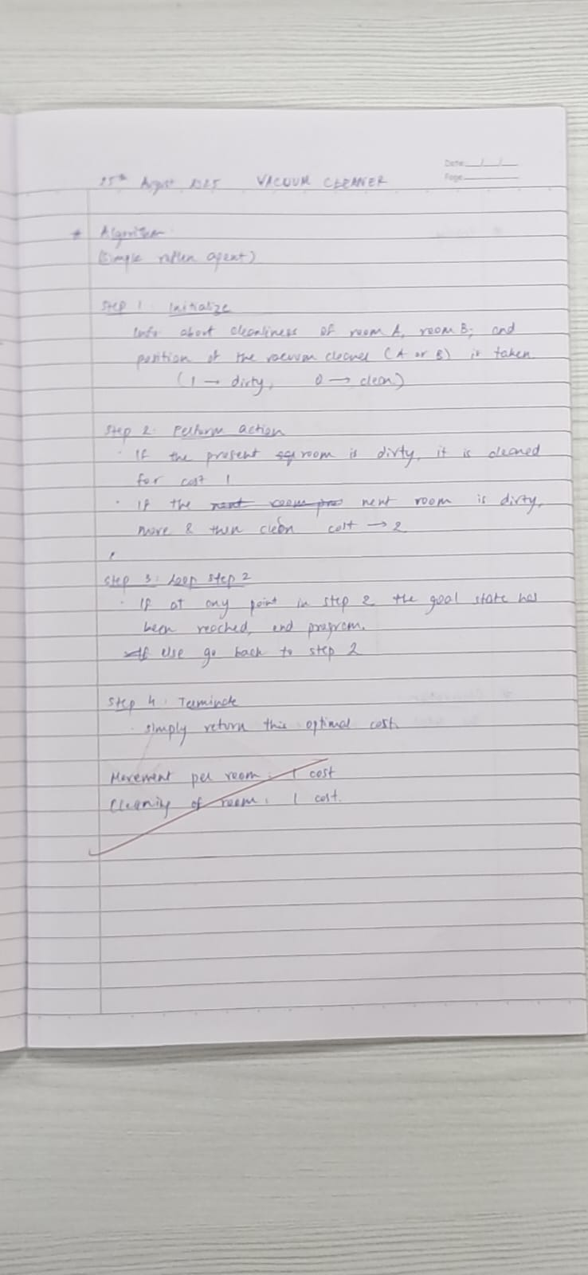

**Syntax:**

**def vacuum_world():**

**# 0 indicates Clean and 1 indicates Dirty**

**goal_state = {'A': '0', 'B': '0'}**

**cost = 0**

**# User input for the initial state**

**location_input = input("Enter Location of Vacuum: ")**

**status_input = input(f"Enter status of {location_input}: ")**

**status_input_complement = input("Enter status of other room: ")**

**print(f"Initial Location Condition: {goal_state}")**

**if location_input == 'A':**

**print("Vacuum is placed in Location A")**

**# Location A is Dirty**

**if status_input == '1':**

**print("Location A is Dirty.")**

**# Suck the dirt and mark it as clean**

**goal_state['A'] = '0'**

**cost += 1 # Cost for suck**

**print(f"Cost for CLEANING A: {cost}")**

**print("Location A has been Cleaned.")**

**# If B is Dirty**

**if status_input_complement == '1':**

**print("Location B is Dirty.")**

**print("Moving right to the Location B.")**

**cost += 1 # Cost for moving right**

**print(f"COST for moving RIGHT: {cost}")**

**# Suck the dirt and mark it as clean**

**goal_state['B'] = '0'**

**cost += 1 # Cost for suck**

**print(f"COST for SUCK: {cost}")**

**print("Location B has been Cleaned.")**

**else:**

**print(f"No action: {cost}")**

**print("Location B is already clean.")**

**# Location A is Clean**

**elif status_input == '0':**

**print("Location A is already clean.")**

**# If B is Dirty**

**if status_input_complement == '1':**

**print("Location B is Dirty.")**

**print("Moving RIGHT to the Location B.")**

**cost += 1 # Cost for moving right**

**print(f"COST for moving RIGHT: {cost}")**

**# Suck the dirt and mark it as clean**

**goal_state['B'] = '0'**

**cost += 1 # Cost for suck**

**print(f"Cost for SUCK: {cost}")**

**print("Location B has been Cleaned.")**

**else:**

**print(f"No action: {cost}")**

**print(cost)**

**print("Location B is already clean.")**

**else: # Vacuum is placed in Location B**

**print("Vacuum is placed in location B")**

**# Location B is Dirty**

**if status_input == '1':**

**print("Location B is Dirty.")**

**# Suck the dirt and mark it as clean**

**goal_state['B'] = '0'**

**cost += 1 # Cost for suck**

**print(f"COST for CLEANING: {cost}")**

**print("Location B has been Cleaned.")**

**# If A is Dirty**

**if status_input_complement == '1':**

**print("Location A is Dirty.")**

**print("Moving LEFT to the Location A.")**

**cost += 1 # Cost for moving left**

**print(f"COST for moving LEFT: {cost}")**

**# Suck the dirt and mark it as clean**

**goal_state['A'] = '0'**

**cost += 1 # Cost for suck**

**print(f"COST for SUCK: {cost}")**

**print("Location A has been Cleaned.")**

**else:**

**print(cost)**

**print("Location B is already clean.") # Note: This seems logically misplaced but preserved as per instructions.**

**# Location B is Clean**

**elif status_input == '0':**

**# If A is Dirty**

**if status_input_complement == '1':**

**print("Location A is Dirty.")**

**print("Moving LEFT to the Location A.")**

**cost += 1 # Cost for moving left**

**print(f"COST for moving LEFT: {cost}")**

**# Suck the dirt and mark it as clean**

**goal_state['A'] = '0'**

**cost += 1 # Cost for suck**

**print(f"Cost for SUCK: {cost}")**

**print("Location A has been Cleaned.")**

**else:**

**print(f"No action: {cost}")**

**print("Location A is already clean.")**

**# Done cleaning**

**print("GOAL STATE:")**

**print(goal_state)**

**print(f"Performance Measurement: {cost}")**

**# Calling the function to run the program**

**vacuum_world()**

**Output:**

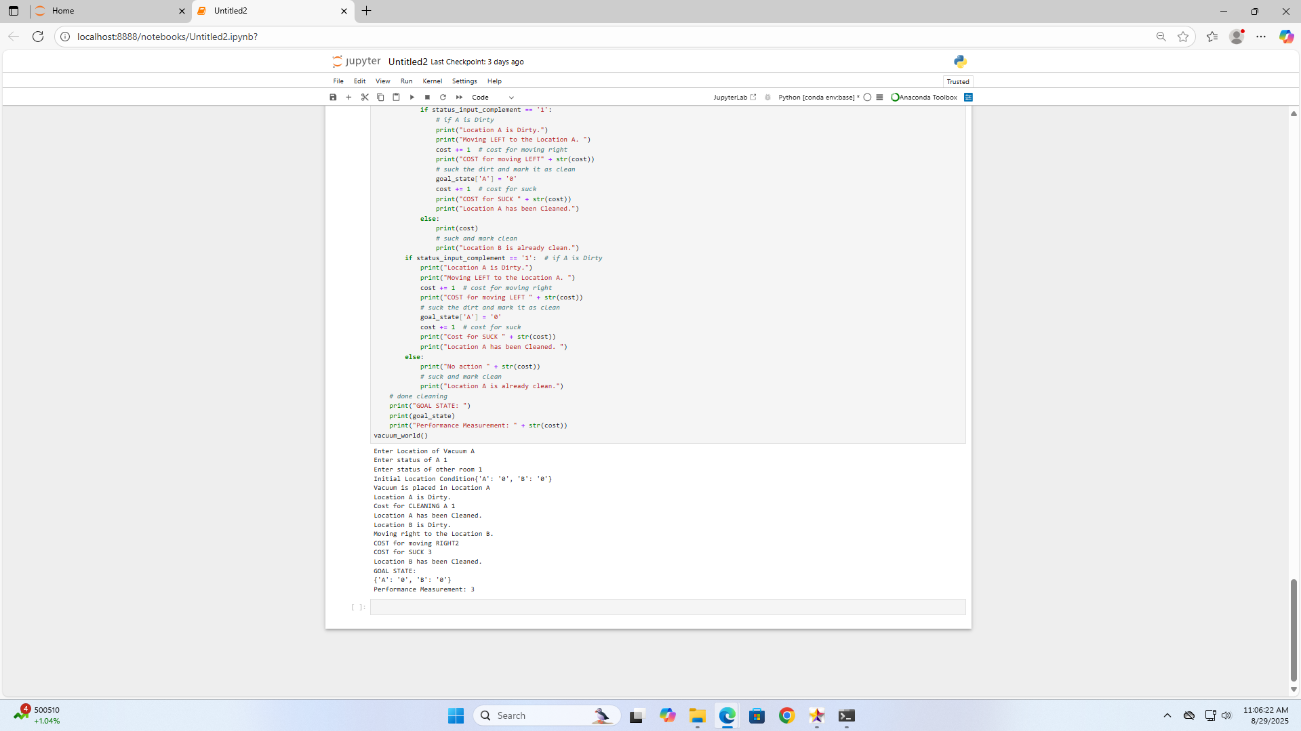

**Tracing:**

